# Last Country by Name

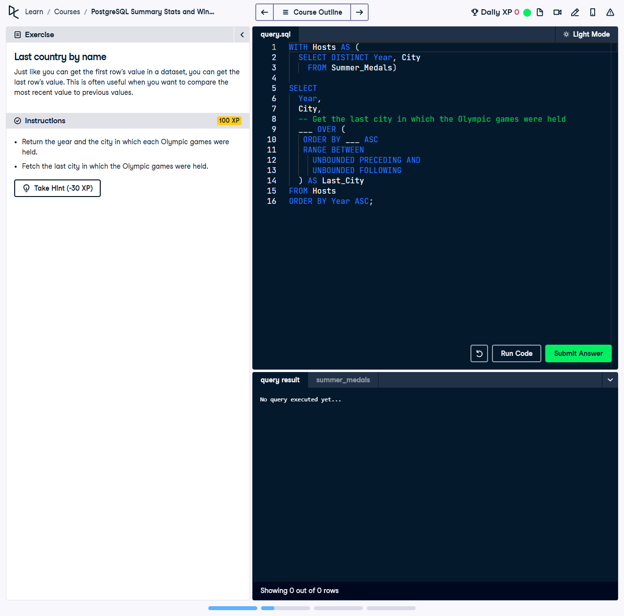

Just like you can get the first row’s value in a dataset, you can get the last row’s value. This is often useful when you want to compare the most recent value to previous values.

This exercise involves using a Common Table Expression (CTE) and the `LAST_VALUE` function to fetch the most recent host city of the Olympic games for every year in the dataset.

## Correct Answer

WITH Hosts AS (  
 SELECT DISTINCT  
 Year,  
 City  
 FROM Summer_Medals  
)  
SELECT  
 Year,  
 City,  
 LAST_VALUE(City) OVER (  
 ORDER BY Year ASC  
 RANGE BETWEEN UNBOUNDED PRECEDING AND UNBOUNDED FOLLOWING  
 ) AS Last_City  
FROM Hosts  
ORDER BY Year ASC;

Explanation of the query:

1. `WITH Hosts AS (...)`: This CTE extracts unique year-city pairs from the dataset, ensuring each Olympic host city is listed once for its year.

2. `LAST_VALUE(City) OVER (...) AS Last_City`: The `LAST_VALUE` function fetches the most recent city to host the Olympic games across all years in the dataset.

3. `RANGE BETWEEN UNBOUNDED PRECEDING AND UNBOUNDED FOLLOWING`: Expands the window to include all rows, ensuring the `LAST_VALUE` always reflects the last host city in the entire dataset.

4. `ORDER BY Year ASC`: Sorts the final output in ascending order of years, aligning it chronologically.